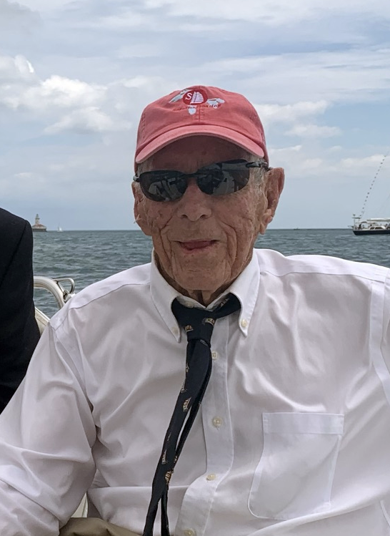
Richard (Dick) Stearns
September 4, 1927 – January 25, 2022
Dick Stearns was one of the best sailors to ever come out of the Midwest. Dick grew up on the south side of Chicago moving to the north side after his father died when he was 16. At 14 years old his father gave him a Star boat to keep him out of mischief. With no formal training or instruction, he went from last place in the fleet and, with Gary Comer, won his first Great Lakes Championship at 17 years old.

Dick attended South Shore High School and Drake University. He bought the sail making company Murphy & Nye from Harry Nye in 1952. The company had made parachutes during the war but was not making sails at the time. Soon Dick would be making sails for customers around the world including kings and princes. In 1954, Carlos de Cardenas (from Cuba) won the World’s Championship in the Star class with one of the first Orlon sails, which solidified Dick’s company as a leader in the industry. Dick patented the machine sewn bolt rope. Before that the rope that attached the sail to the mast was hand sewn on the sail. Murphy & Nye also pioneered the cross-cut sail when Orlon and Dacron came out. Prior to Orlon, sails were made of cotton and were miter cut. Dick’s company would go on to become the dominant force in one-design sails for the next 25 years. Even Lowell North used Murphy & Nye sails prior to starting North Sails. An incredible group of famous sailors worked at Murphy & Nye. At one point Murphy & Nye sails dominated most one design classes and all of the Olympic sailing classes.

In 1950 Dick won his first of eight Northern Hemisphere Championships. Along with winning five Great Lakes Star Class championships, he won his first of two North American Championships in 1960. Then in 1962 he won the Star Class Worlds Championship in Portugal with long time crew Lindsey Williams. The fleet of 73 boats from 19 nations shattered the record for most boats at a Star Class Worlds. https://starclass.org/history/1962-world-championship-cascais-portugal . The next year Dick won a Gold Medal at the Pan American Games with crew Buck Halperin, and in 1964 he won a silver medal in the Tokyo Olympics with crew Lindsey Williams. Dick’s Olympic contribution didn’t stop with a silver medal. He was the assistant Olympic coach in 1968 and then the Olympic Sailing coach in 1972 and 1976. He was the Chairman of the US Olympic Committee for 8 years and coach of the US Pan American team in 1971 and 1975. He was the Vice President of the United States Yacht Racing Union (now U. S. Sailing)

Dick sailed the first Etchells in the trial against the Soling to determine which boat would be the new Olympic class. The Etchell won hands down but politics got in the way, so the Soling became the new Olympic 3 man keel boat. Dick won the first Etchells Great Lake Championship in 1976. He also was second in the Soling North Americans

In the mid 70’s Dick moved on to sailing larger boats. He was one of the co-founders of the Chicago T-10 fleet. In 1978, he won the first of his two T-10 North American Championships. He went on to win multiple Mackinac races with his T-10s Dora and Glider. In 2000, Dick sailed his 35-year-old Cal 40 to first overall in the Millennium 600 Port Huron to Chicago race, beating boats like the new Maxi boat Magnitude, an Andrews 70. Dick sailed 53 Mackinac races, sailing on famous boats Dyna, Dora, Inferno, Bay Bea as well as his own Cal 40 and T-10’s. His last Mac races were sailed on J/Boats with his son Rich and daughter-in-law Lori.

Sailing was not Dick’s only love. He flew airplanes before he could drive. From a T-6 and a Navion to multiple Bonanza’s and Cessna 310s, he flew into his 80s. Then he picked up model airplane flying which he continued until his death. He was an honorary member of his remote-controlled flying club in Richmond, IL.
Dick was not very good at relaxing but when he was at his farm in southwest Wisconsin, he came close to it by mowing trails, playing with his dogs and enjoying his family.
Dick co-founded Lands’ End with Gary Comer and Robert “Buck” Halperin. In the 50’s he was part of the Lord Calvert Canadian Whiskey “Man of Distinction” ad campaign. In the 60’s he lent his name to an upstart life jacket company and he was part of the Illinois Pheasant hunting team, where they gave him the most shells because dead eye Dick didn’t miss. He was a skeet shooter his entire life starting in his teens when there were gun clubs on Lake Michigan. Normal scores of 23 to 25 (perfect score) were common for Dick. He was a long-time board member of the Sea Scouts and was a member of Chicago Yacht Club since 1942.
Dick is survived by his partner and special friend Bernice DeWeerd, his sons Richard (Lori), Chris, his daughters Susie (Bill) Allen and Barbie (Dave) Alampi and his eight grandchildren and five great grandchildren.
Dick was a kind, gentle soul and was loved and admired by all. He will be buried in the Stearns family plot at Graceland Cemetery, Chicago. A memorial service will be held at Belmont Yacht Club in the Spring.
He died peacefully at home in Delavan, WI with family members at his side.
https://starclass.org/history/richard-i.-stearns-profiles-of-star-champions
https://en.wikipedia.org/wiki/Richard_Stearns_(sailor)

